***Arab American University***

***Faculty of Engineering and Information Technology***

***Computer Systems Engineering***

**SENIOR PROJECT I**

*Project Title Here …*

*2025/2026*

|  |  |
| --- | --- |
| First Name Last Name (ID) | First Name Last Name (ID) |
| First Name Last Name (ID) | First Name Last Name (ID) |

|  |
| --- |
| Supervised by: *Dr. Tareq Zanoon* |

|  |
| --- |
| **Computer Systems Engineering Dept.**  **Submitted in partial fulfillment of the requirements of B.Sc. Degree in Computer Systems Engineering**  ***Insert Date Here*** |

**Students Statement**

We, the undersigned students, certify and confirm that the work submitted in this project report is entirely our own and has not been copied from any other source. Any material that has been used from other sources has been properly cited and acknowledged in the report.

We are fully aware that any copying or improper citation of references/sources used in this report will be considered plagiarism, which is a clear violation of the Code of Ethics of the Arab American University.

|  |  |
| --- | --- |
| First Name Last Name (ID) | First Name Last Name (ID) |
|  |  |
|  |  |
| First Name Last Name (ID) | First Name Last Name (ID) |

**Supervisor Certification**

This to certify that the work presented in this senior year project manuscript was carried out under my supervision, which is entitled:

“**SDP Title Goes Here**”

|  |  |
| --- | --- |
| *First Name Last Name (ID)* | *First Name Last Name (ID)* |
| *First Name Last Name (ID)* | *First Name Last Name (ID)* |

I hereby that the aforementioned students have successfully finished their senior year project and by submitting this report they have fulfilled in partial the requirements of B.Sc. Degree in Engineering.

I also, hereby that I have **read, reviewed and corrected the technical content** of this report and I believe that it is adequate in scope, quality and content and it is in alignment with the ABET requirements and the department guidelines.

*Dr. Tareq Zanoon,*

**ACKNOWLEDGMENT**

We would like to express our sincere gratitude and appreciation to all those who contributed to the successful completion of this senior project.

First and foremost, we extend our deepest thanks to Dr. Tareq Zanon, our project supervisor, for his invaluable guidance, continuous support, and expert advice throughout the development of this project. His mentorship and constructive feedback were instrumental in shaping our work and ensuring its successful completion.

We are grateful to the Arab American University and the Computer System Engineering Department for providing us with the necessary academic environment, resources, and facilities that enabled us to pursue this challenging and rewarding project.

We would like to acknowledge the collaborative efforts of our team members: Mohammad Atteyah, Ahmad Khaldy, and Loay Hamamdi. Their dedication, technical expertise, and teamwork were essential to overcoming the various challenges encountered during the development of our Rubik's cube solving robot.

We extend our heartfelt appreciation to our parents for their unwavering support, encouragement, and patience throughout our academic journey. Their belief in our abilities and their continuous motivation have been a source of strength and inspiration.

Finally, we thank everyone who directly or indirectly contributed to the success of this project. Their support and encouragement have made this achievement possible.

**ABSTRACT**

This project presents the design and implementation of an autonomous robot capable of solving a 3×3 Rubik's cube using Kociemba's algorithm. The primary objective of this work is to integrate and apply the knowledge and skills acquired throughout our Computer System Engineering studies while exploring new technical competencies in robotics, computer vision, and algorithm implementation.

The system consists of a Raspberry Pi as the main processing unit, coupled with cameras for cube state detection, motors for mechanical manipulation, and supporting structural components. The robot operates by first scanning and analyzing all six faces of the Rubik's cube using computer vision techniques to determine the current scrambled state. Once the cube configuration is captured and processed, the system applies Kociemba's algorithm to calculate an optimal solution sequence. The robot then executes the solution by systematically rotating the cube faces using precisely controlled motors until the puzzle is completely solved.

The project demonstrates the successful integration of multiple engineering disciplines, including embedded systems programming, computer vision, mechanical design, and algorithmic problem-solving. Developed using Python programming language, the system showcases the practical application of theoretical concepts learned during our academic program. This work contributes to the field of educational robotics and serves as a comprehensive demonstration of autonomous puzzle solving capabilities, bridging the gap between algorithmic theory and practical robotic implementation.

**TABLE OF CONTENTS**

LIST OF FIGURES iii

LIST OF TABLES iv

LIST OF SYMBOLS AND ABBREVIATIONS ….. v

**1** **CHAPTER 1: INTRODUCTION** 1

1.1 Problem Statement and Purpose 1

1.2 Project and Design Objectives 1

1.3 Intended Outcomes and Deliverables 1

1.5 Summary of Report Structure 1

**2** **CHAPTER 2: BACKGROUND**  2

2.1 Overview 2

2.2 Related Work 2

**3** **CHAPTER 3: METHODS AND MATERIALS** 3

3.1 System Design and Components 3

3.2 Design Specifications, Standards and Constraints 3

3.3 Design Alternatives 3

3.4 System Analysis and Optimization 3

3.5 Simulation and/or Experimental Test 3

**4** **CHAPTER 4: RESULTS AND DISCUSSIONS** 4

4.1 Results 4

4.2 Discussions 4

**5** **CHAPTER 5: PROJECT MANAGEMENT** 5

5.1 Tasks, Schedule and Milestones 5

5.2 Resources and Cost Management 5

5.3 Lessons Learned 5

**6** **CHAPTER 6: IMPACT OF THE ENGINEERING SOLUTION** 6

6.1 Economical, Societal and Global 6

6.2 Environmental and Ethical 6

6.3. Other Issues 6

**7** **CHAPTER 7: CONCLUSIONS AND RECOMMENDATIONS** 7

7.1 Summary of Achievements of the Project Objectives 7

7.2 New Skills and Experiences Learnt 7

7.3 Recommendations for Future Work 7

**REFERENCES** 8

**APPENDICES** 9

Appendix A: 9

Appendix B: 9

Appendix C: 9

***Note (Delete these lines):*** *The section titles in each chapter are guidelines and you may modify the titles or add other section titles and/or subtitles in consultation with your project advisor as there may be variations in the departmental requirements.*

*(Senior Project I chapters 1 -3),*

*(Senior Project II All chapters)*

**LIST OF FIGURES**

*Figure Page*

Fig. 1. Mercury 12

Fig. 2. Venus 13

Fig. 3. Earth 14

Fig.4. Mars 15

**LIST OF TABLES**

*Table Page*

Table. 1. Mercury 12

Table 2. Venus 13

Table 3. Earth 14

Table 4. Mars 15

**LIST OF SYMBOLS AND ABBREVIATIONS**

This is where you should put all the symbols used and abbreviations **(must be sorted)**. It is stored in a table format same as the table of contents. Use inserts a row to add more entries….etc

|  |  |
| --- | --- |
| **LIST OF SYMBOLS** | |
| **ω** | Angular velocity in rad/s |
| **ξ** | Damping ratio |
|  |  |
| **LIST OF ABBREVIATIONS** | |
| **ABET** | Accreditation Board For Engineering And Technology |
| **EC** | Examining Committee |
| **PC** | Project Committee |
| **STEM** | • **S**cience  • **T**echnology  • **E**ngineering  • **M**athematics |

1. **CHAPTER 1: INTRODUCTION**

This project focuses on the design and implementation of an autonomous robot capable of solving a 3×3 Rubik's cube, integrating multiple engineering disciplines including computer vision, mechanical design, embedded systems, and algorithmic implementation. The challenge lies in creating a robust physical system capable of precise cube manipulation and reliable state detection while applying the knowledge gained throughout our Computer System Engineering studies.

We chose Kociemba's algorithm because it finds efficient solutions with a low number of moves, often under 21 steps. It's fast, well documented, and works well with the standard 3×3 cube structure. This makes it ideal for real time solving in a robotic system, where fewer moves mean less mechanical complexity and faster results. However, implementing this algorithm in a physical robotic system presents several significant technical challenges. Color detection requires accurately identifying the cube's colors using a camera under different lighting conditions, which can be particularly difficult. Mechanical control involves designing a stable and precise system to rotate the cube faces without slipping or misalignment. Integration challenges arise from ensuring that hardware components including motors and cameras work seamlessly with software systems encompassing vision processing and algorithm implementation in real time. Additionally, calibration requires precise alignment of the camera, cube positioning, and mechanical arms for consistent operation.

This project provides an excellent opportunity to apply and integrate knowledge gained throughout our Computer System Engineering program. The embedded systems component involves programming and controlling the Raspberry Pi while interfacing with various sensors and actuators. Programming skills are utilized through writing comprehensive Python code for image processing, control logic, and algorithm implementation. Computer vision techniques are employed to detect and accurately read the cube's face colors under varying conditions. Our understanding of algorithms and data structures is crucial for implementing and optimizing Kociemba's solving algorithm for real time performance. Finally, hardware design principles guide the development and assembly of the mechanical system using motors and structural components.

This project demonstrates the practical application of Computer System Engineering principles through the development of an autonomous cube solving system. The primary objective is to create a robot that can independently solve a Rubik's cube while showcasing the integration of multiple technical disciplines learned throughout our academic program.

The scope of this project encompasses the complete design and implementation of an autonomous Rubik's cube solving robot. The main objectives include developing a robust computer vision system for accurate cube state detection, implementing Kociemba's algorithm for efficient solution generation, designing and constructing a reliable mechanical manipulation system, integrating all components using a Raspberry Pi based control system, and demonstrating successful autonomous cube solving capabilities. The expected outcomes include a fully functional robot capable of consistently solving scrambled 3×3 Rubik's cubes, comprehensive documentation of the design and implementation process, and demonstration of the practical application of Computer System Engineering principles in a real world robotics project.

* 1. Problem Statement and Purpose

This project addresses the technical challenge of designing and implementing an autonomous robotic system that can detect, analyze, and solve a scrambled 3×3 Rubik's cube without human intervention. The system must integrate computer vision for cube state recognition, Kociemba's algorithm for solution computation, and precise mechanical control for cube manipulation using Raspberry Pi based embedded systems.

The purpose of this project is to demonstrate comprehensive application of Computer System Engineering principles through a complex, multi-disciplinary robotics implementation. This project provides practical experience in embedded systems programming, computer vision, mechanical design, and real time algorithm implementation, directly preparing students for industry challenges requiring integration of hardware and software systems. The project serves as an educational platform that bridges theoretical knowledge with practical engineering skills, contributing to STEM education by showcasing how multiple engineering disciplines collaborate to achieve autonomous system functionality.

* 1. Project and Design Objectives
* Solving Speed: The robot shall solve a standard 3×3 Rubik's cube in 30 seconds or less from initial cube scanning to completion.
* Success Rate: The system shall achieve a minimum 90% success rate in correctly solving randomly scrambled 3×3 Rubik's cubes across 20 test attempts.
* Color Detection Accuracy: The computer vision system shall accurately identify all six cube face colors with 95% accuracy under standard indoor lighting conditions.
* To develop our skills in building similar and diverse robotic systems by combining various hardware and software engineering techniques.

* 1. Intended Outcomes and Deliverables

We intend to build a Rubik’s Cube Solving Robot, an embedded mechatronic system capable of automatically solving a standard 3x3 Rubik’s Cube. The robot will consist of a mechanical structure operated by motors to manipulate the cube, a software interface to receive or detect the cube's state, and a solving engine that applies the Kociemba algorithm to determine the optimal move sequence. The key outcome of this project is to demonstrate how embedded systems, control algorithms, and mechanical design can be integrated into a fully automated problem solving machine. This system aims to showcase the practical application of engineering principles in robotics, optimization, and real time control.  
This project is intended as a learning platform and proof of concept for more advanced robotic manipulation systems. We aim to present it at engineering exhibitions and hope to inspire further development in educational robotics or puzzle solving automation. In the future, we aspire to upgrade the system to include computer vision for full autonomy and seek potential sponsorships for developing a more polished product for educational or promotional use.

* 1. Summary of Report Structure

This report is organized into seven chapters. The second chapter provides an overview of the project and discusses related work in the field. The third chapter focuses on the system design and its components, covering design specifications, standards, constraints, design alternatives, system analysis, optimization, and simulation or experimental testing. Chapter four presents and analyzes the project results. Chapter five details the management aspects of the project, including time management, cost management, and lessons learned. Chapter six examines the project's costs, production considerations, and its social and environmental impact. Finally, chapter seven reflects on the project goals achieved, evaluates the level of success, highlights the skills and experiences gained, and offers recommendations for future work.

1. **CHAPTER 2: BACKGROUND**
   1. Overview

The Rubic’s Cube was invented in 1974, it is a three-dimensional puzzle that has fascinated millions around the world, competitions are now held to solve it, attracting people of all ages to try to solve it, solving the cube independently using robots requires the integration of multiple engineering disciplines, including computer vision, mechanical design, embedded system, and algorithm optimization. The challenge lies in creating a system capable of accurately determining the state of the cube, calculating the optimal solation and performing precise mechanical operations to efficiently solve the puzzle.

In this project, we used the Kociemba’s algorithm, a two- phase algorithm that significantly reduces the cube’s solution space, enapling the puzzle to be solved efficiently with the fewest moves, this algorithm is widely known for its balance between speed and optimal solution, making it ideal for robotic applications.

* 1. Related Work

### AI Rubick Cube solver

This is the first project related to our project and this project uses artificial intelligence to solve the Rubik’s Cube puzzle automatically, this project relies on algorithm like BFs, but instead, we worked on the Kociemba’s algorithm because it’s faster and better. This project would require thousands of moves to solve the cube, whereas ours solves the cube in 20 moves or less, this project relied on CNN, but we used cameras.

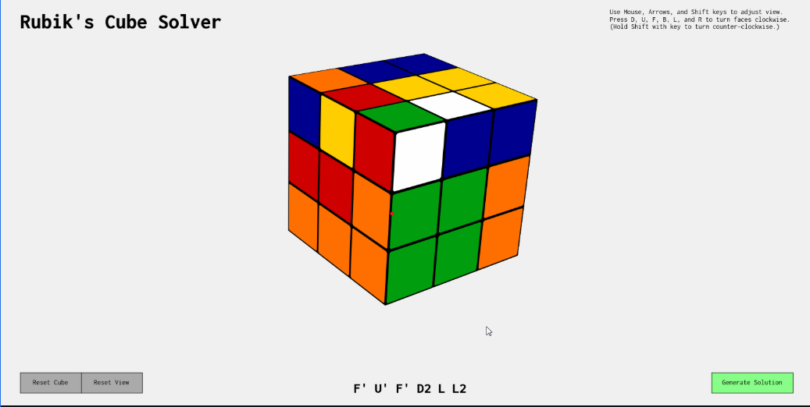

### Robot solves Rubic’s cube

The second project is a physical robot (not just a software simulation) that solves a Rubic’s Cube using motors and sensors. This project also aims to solve a Rubik’s Cube automatically and relies on a camera and motors, it’s similar to our project.

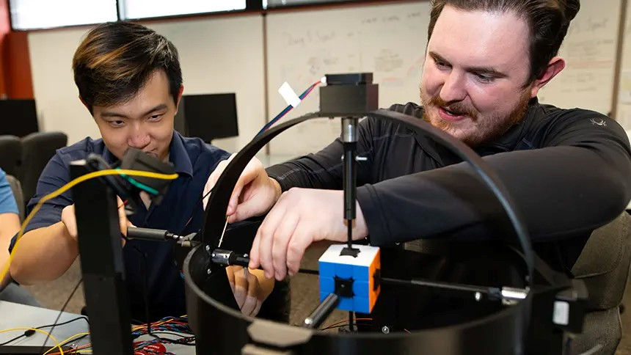

### CubeMoster

The third project is very similar to ours, solving the cube using several algorithms, such as CFOP, DFs and Kociemba’s, which we will use in our project. The main difference between the two projects is that they use an Arduino, a raspberry, and six motors, while our project uses four motors and does not use a Arduino.

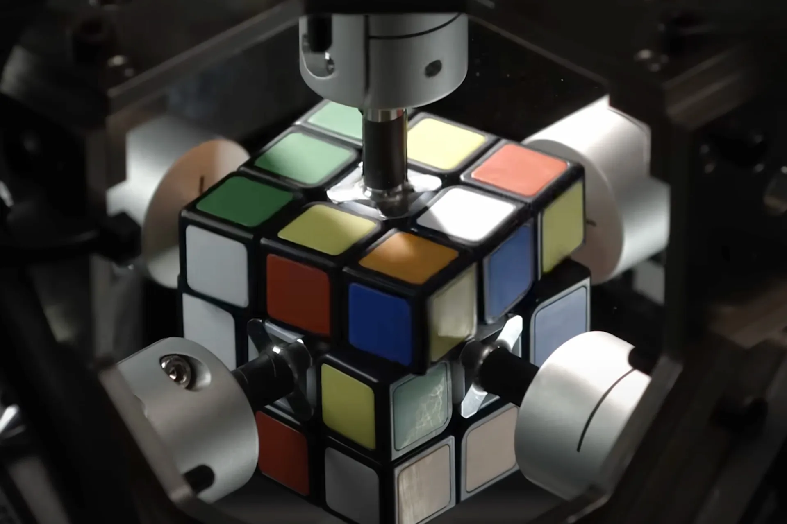

### Solving the Rubik’s cube with deep reinforcement learning and search

In this research, they created an artificial intelligence capable of solving the Rubic’s Cube without the need to study human solutions. It solves the cube in 20 moves, but it is merely a program that does not moves a real cube, this research is purely theoretical, our project is practical, and the cube will be moved by a real robot.

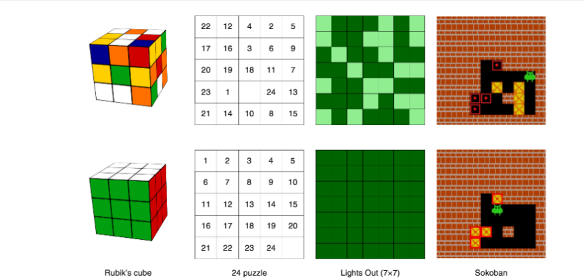

1. **CHAPTER 3: METHODS AND MATERIALS**

In this part of the report please include the specific project details. For example, include description of the approach taken, how problems were solved, detailed system architecture,

* 1. System Design and Components

Present a detailed and complete design for a device that meets your specifications and fulfills the objectives.  Your goal should be to create a design that would allow a competent person with no prior knowledge of how or why your device works to build one from your plans.  If you wish, drawings and other supporting documents may be placed in the Appendix to improve readability.

Includes a description of the work done within the scope of the project by the team and methods used in solving the problem described in the Introduction section. Detail how each component in the project worked.

Required hardware and software tools and accessibility.

* 1. Design Specifications, Standards and Constraints

- Design specifications:

* Hardware Requirements:  
  Raspberry Pi 4 (quad-core ARM Cortex-A72, 4GB RAM minimum)
* Six servo motors (MG996R or equivalent, 15+ kg.cm torque)
* USB camera or Raspberry Pi Camera Module v2 (minimum 720p resolution)
* 5V power supply (minimum 3A capacity)
* Mechanical frame supporting 300mm x 300mm footprint
* Standard 3×3 Rubik's cube compatibility (57mm dimensions)

-Performance Specifications:

* Cube solving time: ≤30 seconds
* Success rate: ≥90% across 20 test attempts
* Color detection accuracy: ≥95% under standard indoor lighting
* Rotation precision: ±2 degrees per servo movement
* Operating temperature: 0°C to 40°C

-Applicable Standards:

Hardware Standards:

* IEEE 1394 (FireWire): For high-speed data transfer between camera and processing unit
* USB 2.0/3.0 Standards: Camera interface and peripheral connectivity
* GPIO Standards: Raspberry Pi GPIO pin configurations and electrical specifications
* PWM Standards: Servo motor control signal specifications (50Hz frequency, 1-2ms pulse width)

Software Development Standards:

* POSIX (IEEE 1003): Unix-like operating system compatibility for Raspberry Pi OS
* Python Enhancement Proposals (PEP): Code style and structure guidelines (PEP 8, PEP 257)
* OpenCV Standards: Computer vision library implementation for image processing
* IEEE 754: Floating-point arithmetic standard for algorithm calculations

Communication Standards:

* I2C Protocol: Inter-integrated circuit communication for sensor interfaces
* SPI Protocol: Serial peripheral interface for high-speed device communication
* UART Standards: Universal asynchronous receiver-transmitter for serial communication

Open Source Standards:

* Linux Kernel Standards: Raspberry Pi OS (Debian-based) compliance
* GNU General Public License (GPL): Open-source software licensing
* Python Software Foundation License: Python interpreter and libraries
* OpenCV BSD License: Computer vision library usage

Quality and Safety Standards:

* ISO 9001: Quality management system guidelines for project development
* IEC 61508: Functional safety standards for electrical systems
* RoHS Directive: Restriction of hazardous substances in electronic components

Design Constraints:

Physical Constraints:

* Maximum system footprint: 300mm × 300mm × 400mm
* Power consumption limitation: ≤15W total system power
* Operating noise level: ≤60dB during cube manipulation
* Component accessibility for maintenance and calibration

Performance Constraints:

* Real-time processing requirements for computer vision algorithms
* Servo motor response time limitations (0.15 sec/60° rotation)
* Memory constraints of Raspberry Pi 4 (4GB RAM maximum)
* Processing power limitations for algorithm optimization

Environmental Constraints:

* Indoor lighting conditions (minimum 200 lux illumination)
* Temperature stability requirements for consistent servo performance
* Vibration isolation to prevent mechanical interference during operation
* Electromagnetic interference considerations for camera and motor operation

Economic Constraints:

* Project budget limitations for component selection
* Cost-effective material choices for mechanical frame construction
* Balance between performance requirements and component costs

Technical Constraints:

* Kociemba's algorithm implementation complexity and optimization requirements
* Computer vision accuracy limitations under varying lighting conditions
* Mechanical precision constraints due to servo motor tolerances
* Integration challenges between hardware and software components

Time Constraints:

* Project development timeline restrictions
* Testing and validation phase limitations
* Documentation and presentation preparation requirements
  1. Design Alternatives

Briefly describe the alternative approaches you considered.  Give reasons for why you rejected each alternative in favor of your proposed solution

* 1. System Analysis and Optimization

Describe the types of analyses and/or experimental work that have been carried out and discuss any work that remains to be done.

* 1. Simulation and/or Experimental Test

Include details of any measurements performed, repeated trials (for validation), error/performance analysis (as a function of system parameters). Include plots, images or tables to describe measurement values.

1. **CHAPTER 4: RESULTS AND DISCUSSIONS**
   1. Results

Summarize the results and draw conclusions based on those results.  Detailed results (e.g., printouts) can be placed in the Appendix to improve readability of the report. experimental results.

* 1. Discussions

Discuss your result that obtains in above section.

1. **CHAPTER 5: Project Management**
   1. Tasks, Schedule and Milestones

You are required to develop the schedule of your senior project which involves identifying the main and sub tasks, investigating task sequences, resource estimations, and task duration estimates to generate the project schedule that also includes milestones which are precise points used to measure the progress toward the final goal. A sample of a project schedule represented in Gantt chart format is shown in figure 5.1.

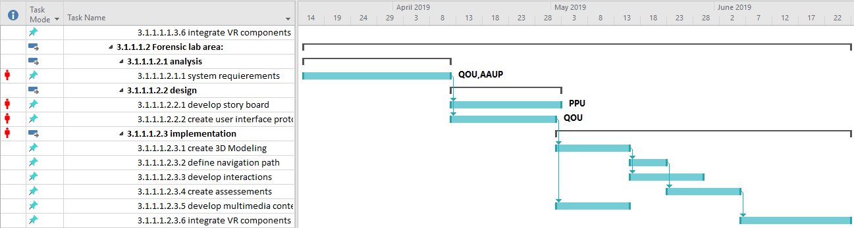

Fig. 5.1 A sample project schedule

* 1. Resources and Cost Management

In this section you have to estimate the needed project resources which involves assessing how many resources—people, tools, equipment, and materials—a project team should use to accomplish project tasks. You have to specify the cost of theses resources where you can fill these costs and calculate the budget of developing the project in a table such as the table below.

Table 5.1 Sample table to fill in total cost of senior project items

|  |  |  |  |  |
| --- | --- | --- | --- | --- |
| Item | # Unit | Unit Cost | Subtotals | Comments |
|  |  |  |  |  |
|  |  |  |  |  |
|  |  |  |  |  |
|  |  |  |  |  |
|  |  |  |  |  |
| Total senior project estimate |  |  |  |  |

* 1. Lessons Learned

You have to document information that reproduces both the positive and negative practices of the senior project.

1. **CHAPTER 6: Impact of the engineering solution**

Sustainability consideration and constraints includes economic, environmental, and social (equity) aspects that need to be evaluated and taken into account in project research and development. There is a strong relationship between these three pillars of sustainability. These need to be considered and incorporated in this section with a discussion on their design constraint and the positive and negative effects of the project within this scope.

* 1. Economical, Societal and Global

Economics (cost) impact: should consider, when relevant,

1. Prototype design and production cost, including the manner in which production cost can be reduced, when applicable.
2. Device cost in mass production, including materials, operations, supports etc.
3. Cost saving of the product should be considered when appropriate. For example, energy savings compared with the use of other products, water saving, reduction in operation cost, etc.
4. Tax incentives to be considered towards final product cost. For example, renewable energy and energy efficient products tax incentives, carbon footprint reduction, etc.
5. Environmental aspects, such as availability of resources, may affect the product cost and therefore price and their market vulnerability.

Social impact of the product: when relevant, please consider

1. How can the developed product impact people lives. Is it a positive or negative impact?
2. What community or personal needs does it address?
3. Is the product going to change consumption patterns?
4. Is the product automating a task currently preformed manually and therefore might impact employment?
5. Does the product create new jobs or fields?
6. Safety aspects and health concerns
7. Regulation constraints that address social and environmental concerns
   1. Environmental and Ethical

Environmental impact of the product: when relevant, please consider

1. Increase or reduction in emissions obtained through modifications in processes that emit greenhouse gasses (GHG) or products that do so.
2. Change in consumption or use patterns, which effect the environment such as use of water, food, energy, wood, etc. (positive or negative affect).
3. Reliance on resources that are scarce (such as precious material) or abundant. For examples, some fuel cells technologies use rare material while other use abundant ones. This will have an impact on the availability of these materials as well as their prices.
4. Project production and operation effect on natural resources availability and competition on the planet resources. Considering their availability in nature and the impact of their consumption on the balance of nature.
5. Environmental regulation

* 1. Other Issues

1. **CHAPTER 7: CONCLUSIONS and RECOMMENDATIONS**
   1. Summary of Achievements of the Project Objectives

Draw conclusions about the level of success of your work.  Did you substantially meet your objectives?  What did you learn in the process?

* 1. New Skills and Experiences Learnt
  2. Recommendations for Future Work

This is one of the most important sections in the Final Report, at least for those who may pick up where you left off.  Knowing what you know now, given the same problem, what would you do if you had it to do all over again?  Understanding that problems of significance are rarely if ever solved perfectly the first time, what would you suggest as the next step toward finding the answer?

**REFERENCES**

1. Rashid M. H., *Power Electronics: Circuits, Devices & Applications*, 4th Ed., Upper Saddle River, New Jersey: Prentice Hall, 2013.
2. Foschini G. J. and Gans M. J., “On Limits of Wireless Communications in a Fading Environment when Using Multiple Antennas,” *Wireless Personal Communications,* Vol. 6, No. 3, pp. 311-335, March 1998.
3. Gans M. J., "A power-spectral theory of propagation in the mobile radio environment,” *IEEE Transactions on Vehicular Technology*, Vol. 21, Issue 1, pp.27-38, 1972.
4. Dahl G., Suttrop F., “Engine Control and Low-NOx Combustion for Hydrogen Fuelled Aircraft Gas Turbines,“ *International Journal of Hydrogen Energy,* Vol. 23, No. 8, pp. 695–704, 1998.
5. Watermark 200SS soil moisture sensor specification manual. Available at http://www.irrometer.com/sensors.html

**APPENDICES**

**Appendix A:**

**Appendix B:**

**Appendix C:**